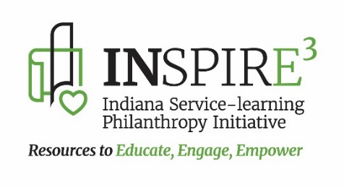

**INSPIRE3** seeks to do exactly what the acronym states as its purpose: Service-Learning and Philanthropy Education Resources to support school administrators, teachers, counselors, and youth development professionals with **free** resources and tools to help them **educate, engage, and empower students through meaningful real-world learning through service**. **INSPIRE3** is facilitated and supported by the **IASP** (Indiana Association of School Principals) and the **IMLEA** (Indiana Middle Level Education Association)

**Visit the** [**INSPIRE3 webpage**](https://iasp.org/about-iasp/inspire3-2/) **located on the** [**IASP website**](https://iasp.org/) **under their About tab and on the** [**IMLEA website**](https://www.imlea.org/) **under the** [**INSPIRE3 tab**](https://www.imlea.org/domain/10)**. Any questions – See the Contact Us page under Professional Development**

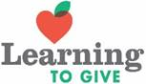

Imagine a world where all youth are knowledgeable and equipped for lifelong engagement in philanthropy as givers of time, talent, and treasure for the common good.  **The Learning to Give website has no cost Philanthropy Education/Service-Learning Lessons and Resources that Teach Giving and Civic Engagement through Academics**.  LTG equips K-12 teachers with lessons and resources to educate students as philanthropists with knowledge, skills, and action to make a better world.  Connect students’ civic lives to academic learning and service-learning. **Over 1700+ K-12 teacher created lesson plans** searchable by keyword, issue area, subject, grade level, theme, calendar event and academic standards.  Add service to your calendar by aligning philanthropy lessons and service-learning projects to monthly events. Browse the Issue Area pages with related lessons and toolkits.  No cost Educator Mini-Courses provide online professional training in philanthropy education and service-learning.  Get Started!! [**www.learningtogive.org**](http://www.learningtogive.org)

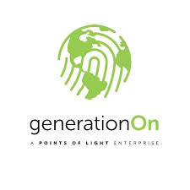

The mission of **generationOn** is to inspire, equip, and mobilize youth to take action that changes the world and themselves through service.  Educators, parents, community organizations, and youth themselves will find **free** resources needed to ignite the power and potential of young people to become leaders and problem solvers, successful students and active community members through service.  **The generationOn website has** **no cost resources** for many audiences that include age-appropriate **issue area project ideas, instructions, how-to guides for K-12 youth, in addition to, service-learning resources, school and clubs programs, and online service and service-learning trackers for educators and teens**.  [**www.generationOn.org**](http://www.generationOn.org)

**Why Philanthropy Education and the Benefits of Service-Learning** -Service-Learning is a teaching and learning strategy that combines real-world application of academic skills/content with service to the community

* Students exhibit more charitable beliefs, attitudes, and behaviors
* Builds ownership and “Why Serve?” of service-learning
* Gives a deeper purpose for learning – students recognize talents and skills to “make a difference”
* Increases student motivation to attend school
* Improves school culture
* Community sees youth as an asset rather than a liability
* Practice different habits of life-long philanthropy
* Broadens perspectives or career opportunities
* Develops critical thinking and leadership skills